Pegasus Project Horse Leader Training Manual

12/30/2015

Welcome to Horse Leader Training

Becoming a horse leader is a fun part of volunteering at The Pegasus Project. If you are interested in becoming a horse leader, you must show commitment by having volunteered as a side walker for a minimum of one 8-week session or 16 arena hours. The next step is to read over this manual thoroughly and then attend the next Horse Leader Training.
Be mindful that Horse Leader training is pass or fail. If you do not pass you may choose to continue to study or practice these skills and are welcome to attend additional horse handling opportunities. These trainings are intended for annual continuing education for approved Horse Leaders and will also give everyone a chance to further their horsemanship skills. You are welcome to re-take Horse Leader Training again if you do not pass the first time.

Horse Leader Rules
“We are here for our riders, but we must do no harm to our horses.”
Please remember, regardless of your experience with horses, it is imperative to adhere to the “Pegasus Way” of handling our therapy horses, for consistency and safety, which may differ greatly from the way you handle your own horses.
- Check the daily schedule before you begin. This will tell you which horses to prepare, what equipment to use, and if there is any rider change.

- Groom and tack the horse; some riders may assist when appropriate. (See tack list or ask instructor).

- Keep noise and tension levels to a minimum in the barn aisle and arena. No yelling, running, or sudden movements around the horses or mounting area. No obscene or discriminatory language.

- Backpacks, purses, or other personal items should be left in your vehicle. Pegasus Project will not be held responsible for loss of personal belongings. Help keep areas clear to avoid tripping or blocking safe passage at all times. Keep aisle-way and tack room clear of unnecessary items.

- No cell phones while horse leading! Leave them in your car or on the volunteer table with the ringer off. This is imperative to keep a safe class environment.

- No dogs are allowed on the property. Not even in your car; please leave your beloved pets at home. They may scare a horse and cause injury to a rider, volunteer, staff or horse. Our insurance does not allow dogs on the property.

- Gather needed tack and supplies before removing a horse from their stall and taking them into the cross tie area.

- Be alert and attentive to the horse you are working with and the other horses around you. Watch their body language for any signs of discomfort or distress.

- Please do not go behind or under (neck or belly) the horse at any time.

- No unnecessary touching of the horses will be allowed during “work” hours– including petting of the head.

- While riders are mounted, please do not open the gates to bring your horse in or out of the arena until asking the instructor for permission. The instructor must have all horses at a halt before the gates can be opened.

- Absolutely NO HITTING or abusive actions towards the horses shall be permitted. The person seen/reported abusing the horse will be immediately pulled from their position and could be terminated from the program. If anyone is seen hitting a horse in the HEAD, the horse has to be immediately pulled from the program for a minimum of one week for a mental evaluation and the abuser will immediately be dismissed.

- Cross Tie Area Rules

2 person limit (+instructor as needed) in the cross-ties.

Never attach a cross-tie to the bridle of the horse. (This includes sidepulls and bitless bridles).
- Horses should never be out of line of sight while in cross ties.
- While horses are in the cross-ties, additional people shall remain behind the yellow and black line and allow Horse Leaders to work directly with riders to tack and untack. Side walkers are there to help riders put away tack; Horse Leaders stay with the horse.
- In the event the rider does not have side walkers, the Horse Leader shall help the rider put away tack as long as staff or trained horse leader is watching the horse.
- Always maintain contact with your horse until they are secured with both cross ties

- Always use a lead rope attached to the halter when leading the horses. Never lead them by the halter even for short distances.

- Always use a bit clip to attach the lead rope to the bit. Never attach the lead rope directly to a bit.

- Mounting & Dismounting:

Mounting

In the Arena/at the block
- DO NOT EVER ATTEMPT TO MOUNT OR TO DISMOUNT THE RIDER BY YOURSELF, always listen for instructor direction for each rider during mount/dismount.
- The Instructor will always initiate each rider’s mount/dismount.
- Position yourself in the halt position; in front of the horse and slightly to one side, and keep the horse steady while the rider mounts.
- When cued by instructor, proceed out of mounting area, along the rail for 3-5 strides (or the first window) before turning to the center of the arena for tack check.

At the Ramp
- Lead the horse through the A gate and stop at the yellow and black line prior to the ramp.
- Wait for Instructor to perform a tack check.
- Do not load the horse in the Ramp until you have been asked to by the Instructor.
- When loading the horse stand 45 degrees off the front of the horse and walk backwards and ask the horse to walk 1 step at a time into the ramp, looking at their ride side girth area.
- Stand 45 degrees in front of the horse while rider is mounting and walk backwards one step at a time when exiting the ramp until volunteers are safely off of the ramp.
- Halt and move into the correct leading position before proceeding to the arena.

Dismounting

In the Arena
- The horses will line up in arena. Be sure to watch your safety spacing (at least 1 horse length 360⁰).
- The Instructor will provide direction for dismounting each rider. When appropriate, the rider will help put their stirrups up and lead their horse out of the arena.
- When ready, horses exit the arena through the A gate, one at a time.
- The horse is taken back to the cross-ties, un-tacked, groomed and returned to the stall.

To the Ramp
- Some riders dismount back at the mounting ramp.
- The horse is brought back up to the ramp through the A gate – the same as if the rider were getting on.

- Use the correct “Safety Spacing” of at least one horse length (360⁰) whenever you are leading a horse whether you have a rider mounted or not.

- Do not allow horses to go nose-to-nose no matter what the situation is!

- When saddling the horses, slowly tighten the cinch, just enough so the saddle won’t fall off. Do not over tighten the cinch, the instructor will check and tighten the cinch before & after mounting.

- Loose Horse:
If a horse gets loose in the arena or on the sensory trail please stay calm and do the following:
- Halt
- Do not leave your horse to catch loose horse
- Listen to the Instructor for further guidance for the specific situation

- Seizures
- Halt
- Horse Leader’s priority is to focus on the horse and use all the techniques in this Manuel and the training to keep the horse calm and relaxed.

- In the Event Rider Falls off Horse
- Yell “Instructor”
- Horse leader leads horse far away from rider
- Other horse leaders shall lead horses and riders away and perform halts.
- Instructor will assess the fallen rider and may have side walkers assist.

- Fire or Earth Quake
- Focus on your horse and keep your horse as calm as you can.
- Listen for instructor prompts for emergency dismount.
- Do your best to move horse away from the rider(s).
- After people have exited the arena proceed to the designated meeting area.

These rules are set in place to physically and emotionally protect our horses’ well-being and to optimize their involvement in our program. Our horses are vital to the success of our clients. These rules are set in place to create a safe environment for everyone involved, and to ensure our horses’ physical, mental and emotional health as a part of our team, as well as insure the safety of our riders and volunteers, including you.

Horse Behavior
While people rely heavily on spoken language to communicate, horses use energy and body language to communicate. Lack of respect or understanding of horse’s language can lead to frustrations for both human and horse.
People are natural born predators, our eyes and minds can focus on a task or object with great intensity without being aware of everything in our surroundings. This has enabled humans to hunt down prey since prehistoric times and we use this ability to focus while we work and play.
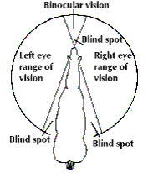

The horse is naturally born as a prey animal; because of this, horses have a heightened sense of awareness to their surroundings. They have the ability to see far more than we could even imagine. Their vision field is much greater than ours and their awareness of their environment is far beyond our capabilities.

So how do we work with horses who are hyper aware of everything around them when we tend to focus in on one or two things at a time?

When we go into the horse’s world, and communicate with their body language, we will gain respect first and trust will follow. This seems very unnatural for us as predators, at first, but with practice we will overcome the language barrier.

We need to understand that horses have evolved a language and a hierarchy within the herd. Humans naturally want to pull horses along and dominate over them as if they were dogs (another predator). While that works with dogs it erodes respect and trust with horses. The horse is a prey animal, they communicate to each other with body language and energy.

Note: The pictures in the manual where taken in the same 30 minute session with the same horse leader and horse. The only difference was the horse leader’s use of her body language to communicate.
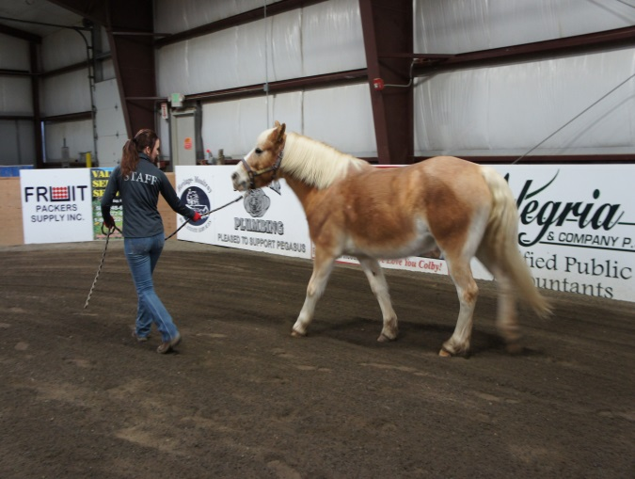
In this first picture the horse leader is looking back, twisting her core (belly button) toward the horse’s face and dragging the horse along with the lead rope. When a horse leader pulls on the lead rope they are acting like a predator and the horse doesn’t see them as a leader of their herd. There is absolutely no chance for the horse leader to gain respect and trust; consequently it actually erodes trust and respect immediately. To compound the situation, the leader is also putting all her core energy and intense eye energy right at the horse’s face. As prey animals horses instinctually know that predators concentrate on their faces and this will further restrict their forward movement. Notice the horse's shoulders, neck and barrel are stiff. This picture does not induce a feeling of harmony between horse leader and horse; what are your thoughts?

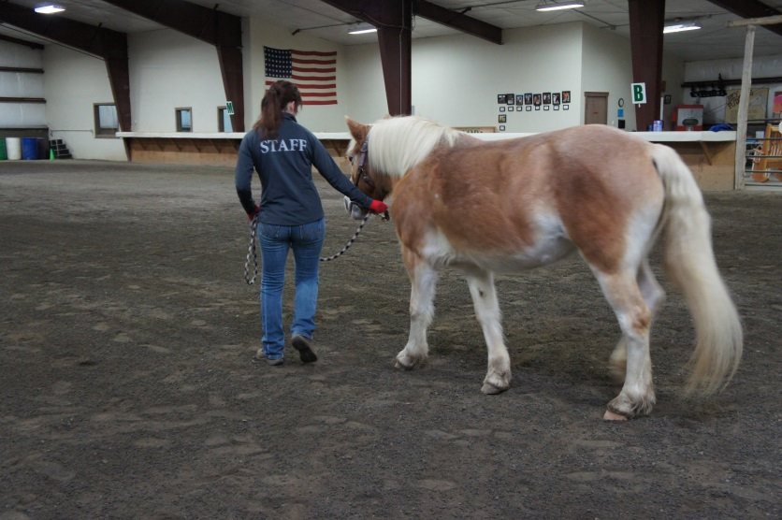
This picture shows the horse leader at the head of the horse, looking ahead, stepping and keeping her core out of the horse’s face. The horse leader has a shorter hold on the lead rope which increases connection to the horse. Holding the lead rope short enables you to block the horse from looking away from you or turning into you. Take a look at the horse’s body language in this photo. The horse’s head is level, her shoulder is soft and her tail is relaxed not tucked close to the rump. All of these signs indicate that the horse leader is communicating effectively with the horse. The horse looks relaxed and willingly following the horse leader’s directions as the horse leader is turning the horse to the right. If you add all this up you could safely conclude, the horse respects and trusts its leader.

Now that we know about horse behavior, let’s look at “The Pegasus Way” to work with horses.
‘The Pegasus Way’

Let’s break down horse language and see what we are unintentionally saying to our horses. Then we will learn how to be intentional with our body language. As mentioned previously, horse language is based on prey behavior which includes pushes and blocks.

Let’s begin with the halt…
Example 1
Example 2

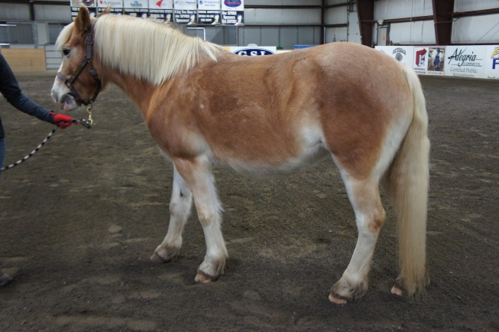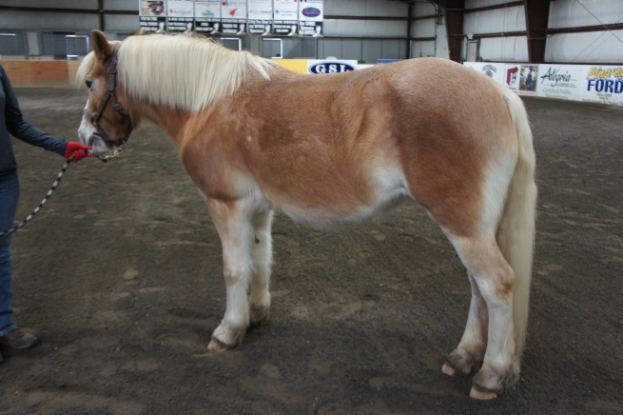

In Example 1, notice how the horse’s front legs are staggard, ( the left is behind the right). The horse is telling us that it plans on standing for a very short time and will soon try to walk off.

In Example 2 the horse has it’s front feet squared up,(side by side), the horse is now telling us that it plans on standing for a long time and will be less likely to walk off. Example 2 is the correct “Halt Position” for stopping in class. The horses absolutely need to be in this “Halt Position” while mounting and dismounting.

Let’s now look at the “Back Up” from the correct “Halt Position.” Remember pulling on the horse stiffens the body and errodes respect and trust. So we need to use our core energy and a block to correctly “Back Up” the horse.
Example 1

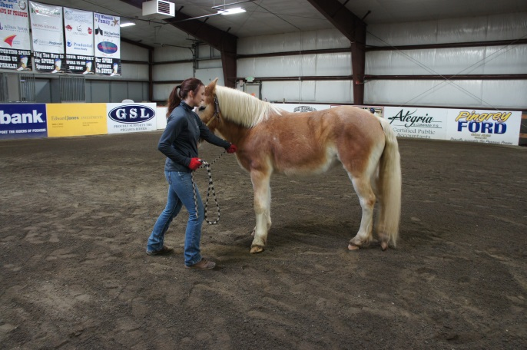
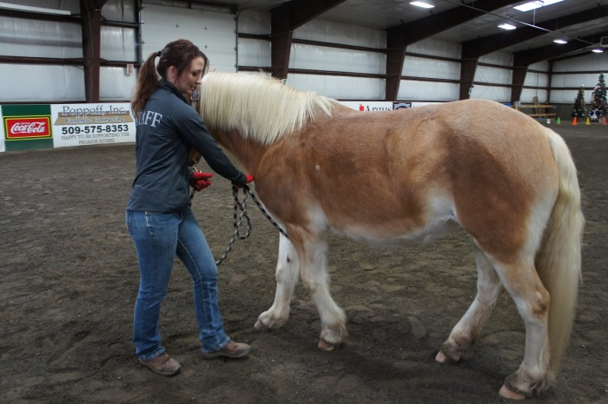

In Example 1 the horse leader is pulling on the lead rope to back the horse. The horse is stiff and is bracing against the horse leader. The horse leader is also not using her core to ask the horse to back up.
Example 2 shows the horse leader holding the lead rope taunt, (not pulling), to block the horse from moving forward and then using her right hand to create a push that is moving the horse backwards. Also her core energy is pointing at the horse’s chest and shoulder which communicates to the horse, “I want you to back.” Notice the horse’s body language; the head is level, body is soft (including its tail), and feet are moving backwards.

Next we will learn how to move forward or “Walk On.” The most important thing to remember when asking for forward motion from your horse is Do Not Pull on the lead rope.

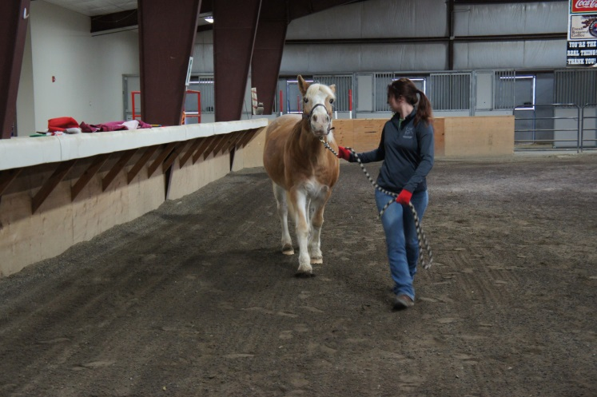
Example 1
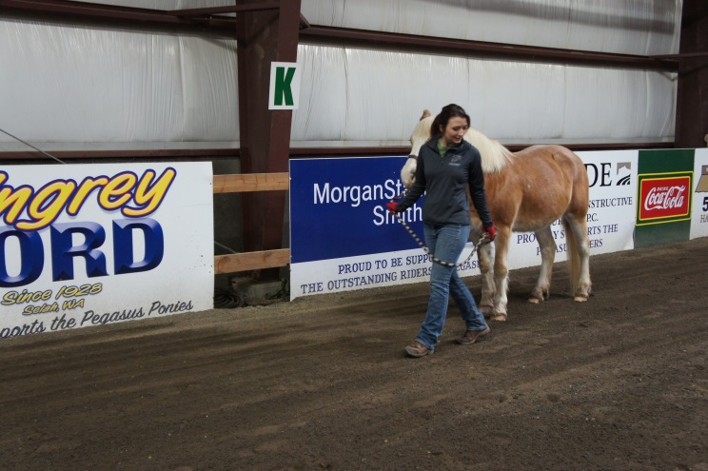

In Example 1 the horse leader is pulling the horse and looking over her right shoulder. The eye energy of the horse leader is directed at the horse’s face and the horse leader’s core is twisted towards the horse’s face creating a block. The horse leader is pulling to move forward while blocking the forward energy with her body language.
In example 2 the horse leader is holding the rope forward but not pulling (very important difference), looking over her left shoulder and reaching back with her left hand to ask the horse to move forward. The energy of the horse leader’s left hand and swinging the tail of the rope towards the girth area asks the horse “Walk On” from their haunches. Notice the horse leader’s hips are facing forward and moving in the desired direction of travel, thus encouraging the horse to move off straight. The horse’s body language is soft and relaxed.

Turning into the horse-
Now that we can “Halt,” “Back Up,” and “Walk On” let us learn to turn the horse. There are two ways to change direction gradually. The first is to turn into the horse and the second is to turn away from the horse. Again we must not pull when we want to turn. Instead hold the lead rope taught and use the lead rope to tell the horse where not to go or i.e. “block the horse.”

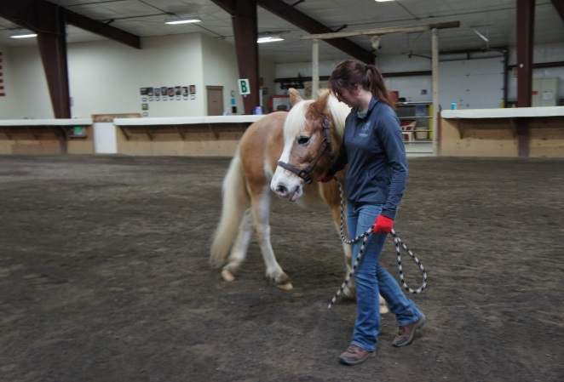
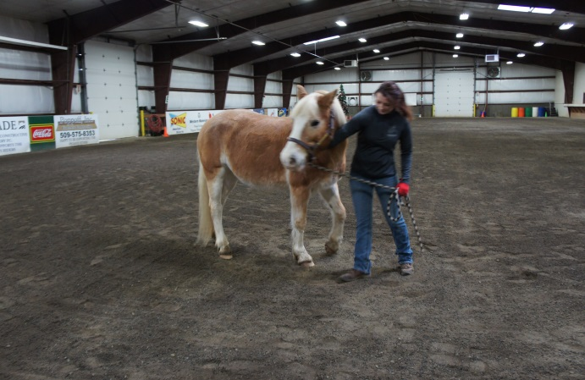

Example 1 shows the horse leader pulling the halter and lead rope to the right while her body language (hips, core & shoulders) is directed away from the horse, which tells the horse to come towards her not away from her. Can you see why this would confuse the horse?
In Example 2, the horse leader is using the lead rope to block the horse from touching her. The Horse leader’s hips are slightly turned into the direction she is traveling. Look carefully at the legs of the horse leader and the horse; Notice that they have their weight planted on their left leg and both are prepared to pick up the right leg. They are in rhythm together. The horse’s facial expression is soft and the body is bending.

Turning away from the horse-

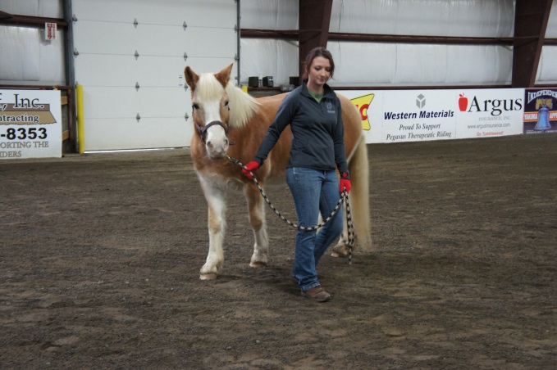
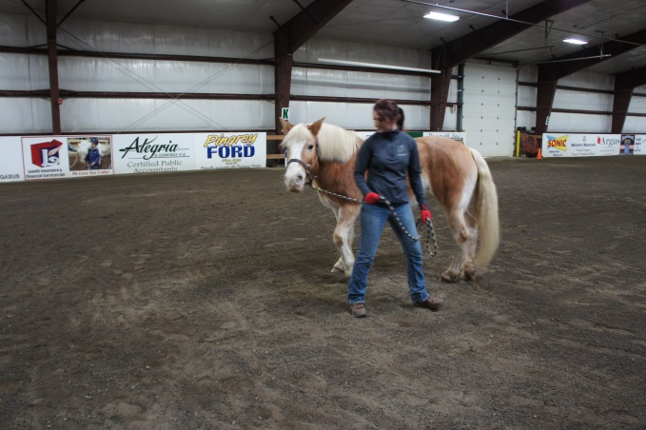

In Example1, the Horse leader is pulling the lead rope while bracing her body against the horse’s head to increase the pull. The Horse leader is looking at the horse’s face, increasing the eye energy that predators use, and her whole body is stiff. A stiff body to a horse means there is something to worry about, something to fight or flee from. The horse is extending its neck to an uncomfortable point because the horse leader is pulling on the lead rope. So instead of moving forward by engaging from the haunches the horse is being dragged and is falling on its forehand, (leaning too much on its front feet,) which inhibits movement and may cause the horse to stumble.
In Example 2, the horse leader is relaxed she is holding her lead rope, to “block” the horse form going the wrong way, but not pulling on it. The horse and the leader are in rhythm with each other’s front feet stepping forward together. The horse leader is pointing her core where she wants to go and has her head turned to keep her horse in her peripheral vision to make sure the horse is following her. The horse’s tail and ears are relaxed, the body is bent and the facial expression is soft. Overall this picture tells us that the horse is happy with the leader.

Maintaining space at the halt-
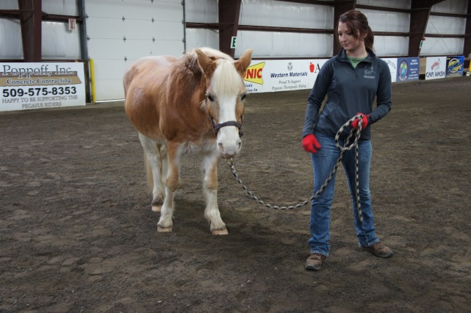
In this picture the horse leader is using a loose rope to show us how to ask a horse to turn away from us. Notice the horse leader’s hip is pushed forward into the horse and the horse leader is looking at the horse. However, the horse leader’s core is still facing forward. To turn the core into the horse’s face would be disrespectful. And the horse simply looks away from the horse leader.

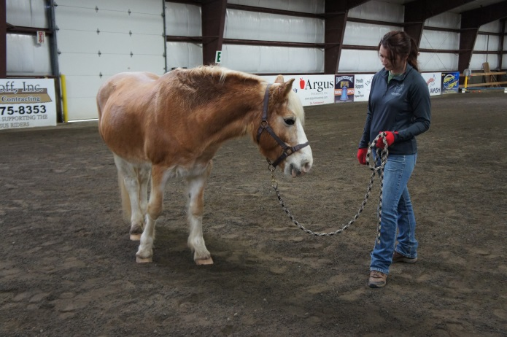
When the horse leader tips her hip back the horse instantly turns into her and shows interest in approaching her. The horse leader could enhance her technique by pulling her belly button in, rounding her back and the horse would feel even more welcomed in.

These tips are important so that we don’t accidently welcome the horses in to our space where they can rub, nip or push us around. If we invite them in and then pull or jerk on the lead rope to move them out of our space we are sending mixed signals. Remember, this erodes respect and trust and may initiate a horses need to take leadership, by pushing us around. Do you feel like a team when the horse is pushing you around?
How to tell if your horse is trying to block you and how to quickly establish communication with your horse-

10-15 minutes before your rider mounts, go into the arena to establish communication with your horse by practicing; first get your horse to “Walk On”, stop and see if the horse tries to cross its face, neck or shoulder in front of you, if the horse does try to cross in front of you, they intend to block you from moving forward. In essence they are asking if you are a leader. If you then pull the lead rope to move them away from you, you have told the horse your leadership is not to be trusted.

Instead, turn your core away from the horse (without moving your feet) so they cannot block your belly button. Then “Walk On” and stop again and repeat until your horse is not confused by your body language. They block your core and you move your core so they cannot block. In this picture the horse is unable to block the horse leader’s core.

In this picture, the horse leader has established Leadership and the horse stopped directly next to the horse leader. The horse is standing square and is relaxed and waiting for further directions. The horse leader is very neutral with her body language so that the horse does not turn its head away or into the leader.

